**System Design & Database Development &**

**Data Dictionary**

**System Diagram**

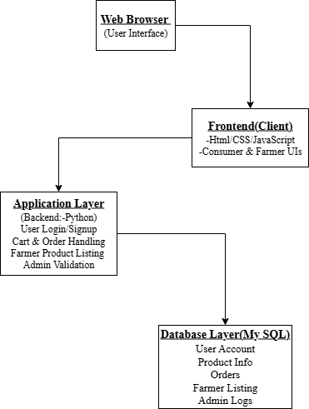

**System Design**

**Design Layout ::**

1. **Home Page**

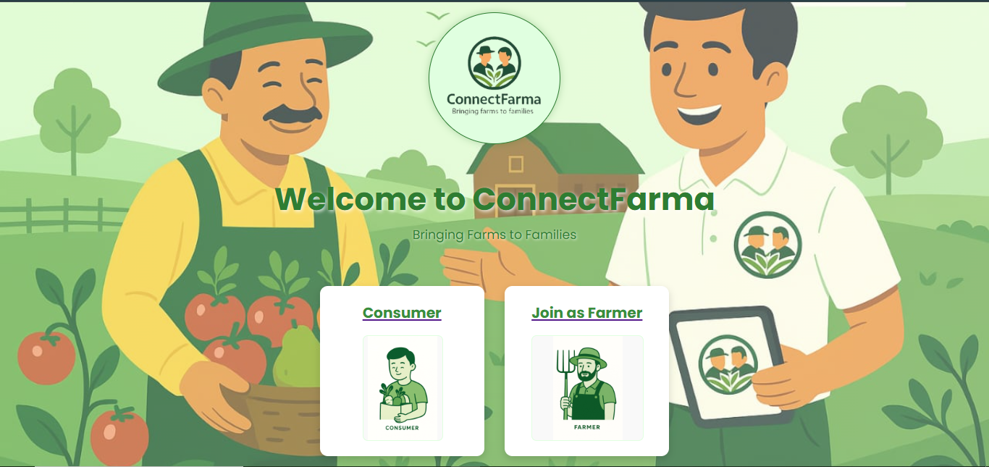

* **Homepage displaying welcome message with options to ‘join as consumer or farmer’.**

1. **Consumer Signup**

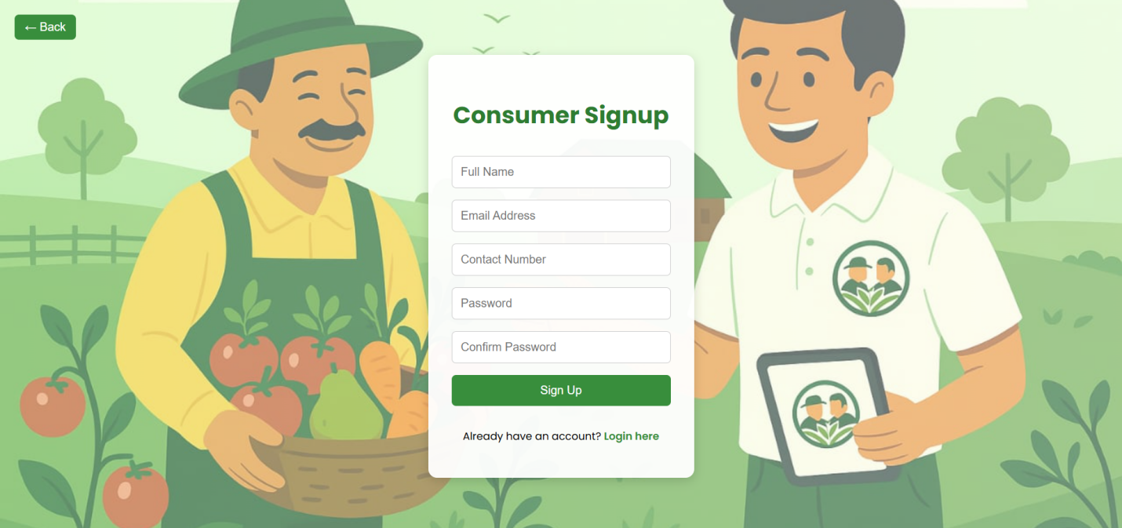

* **Consumer signup page with form fields to register new users.**

1. **Sign Up Credentials**

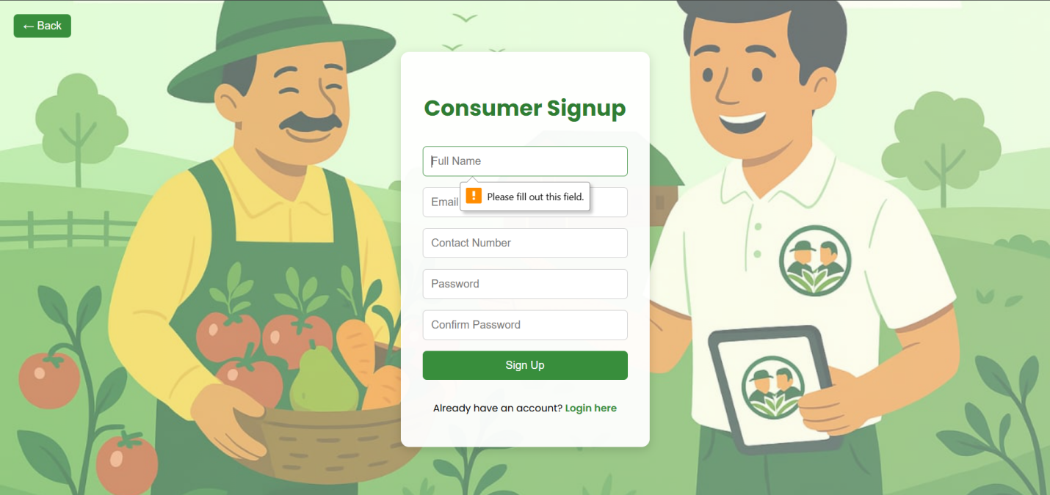

* **Consumers fills in signup credentials to register.**

1. **Sign Up Message**

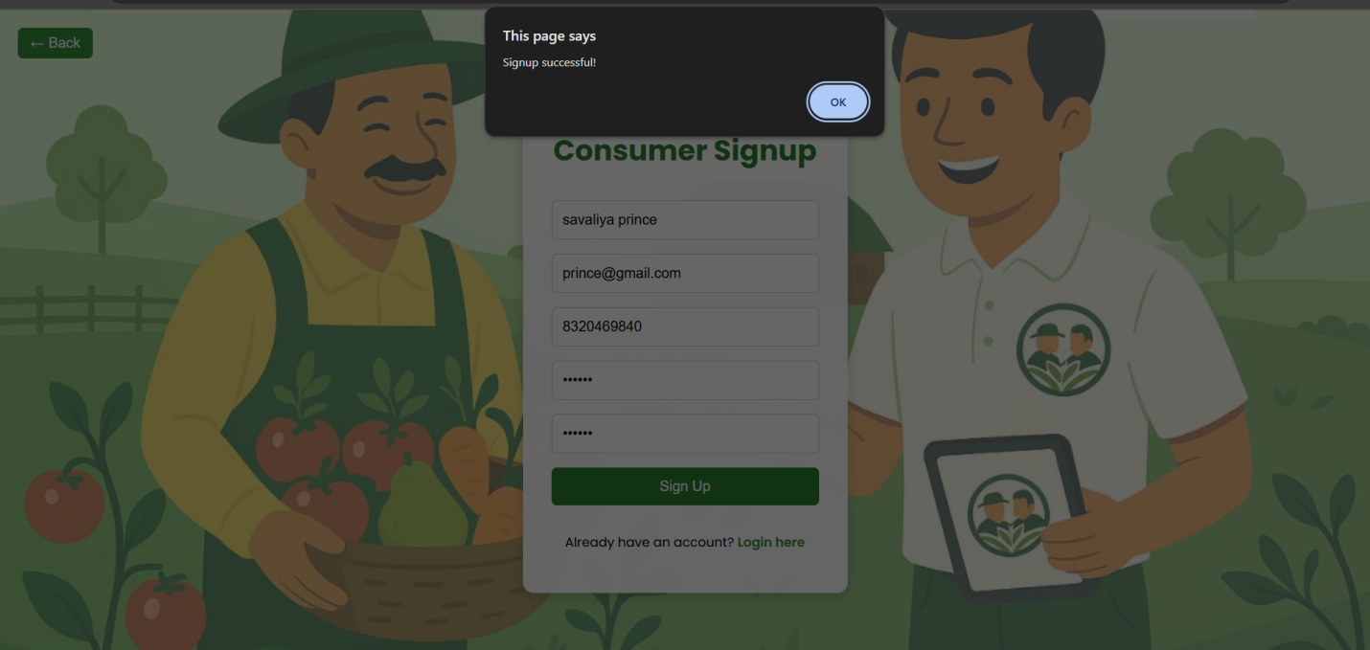

* **Confirmation message appears after successful consumer signup.**

1. **Consumer Login page**

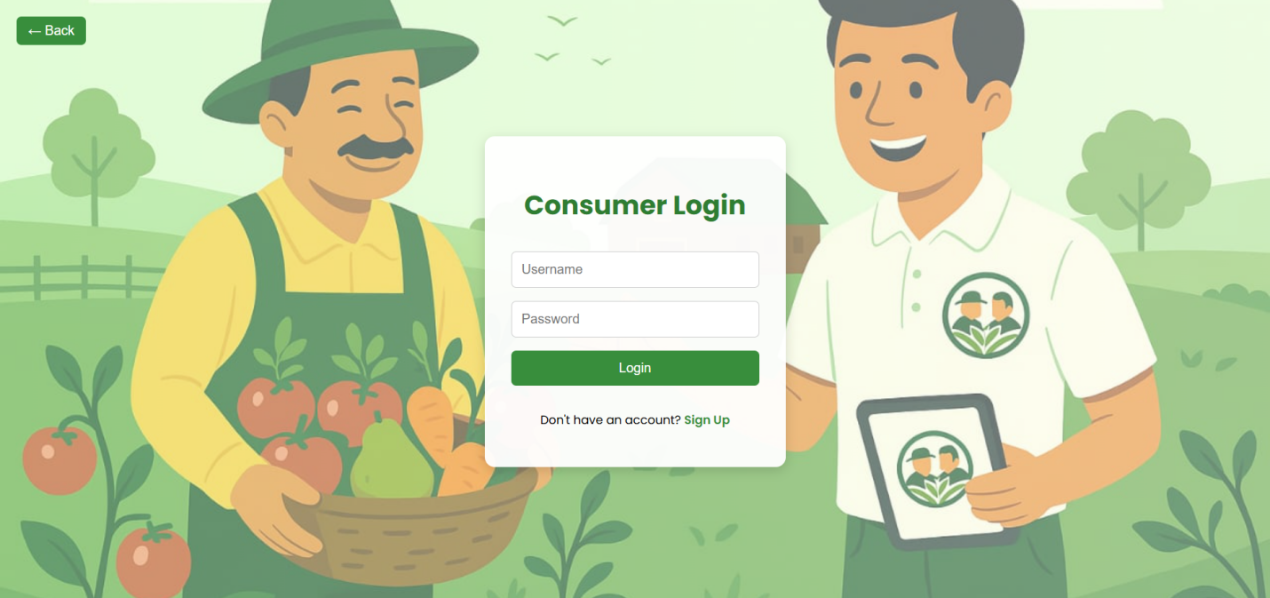

* **Consumer login form to access their account.**

1. **Login Credentials**

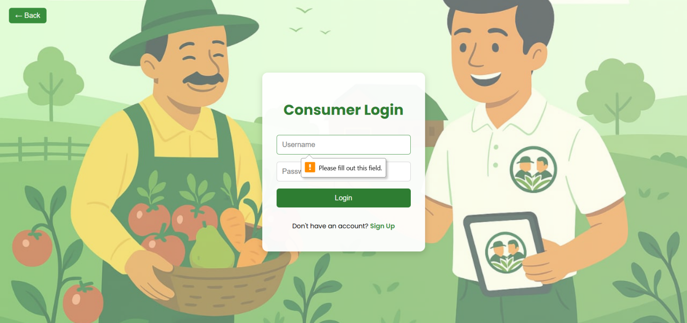

* **Consumer enters their login credentials to proceed.**

1. **Login Detail**

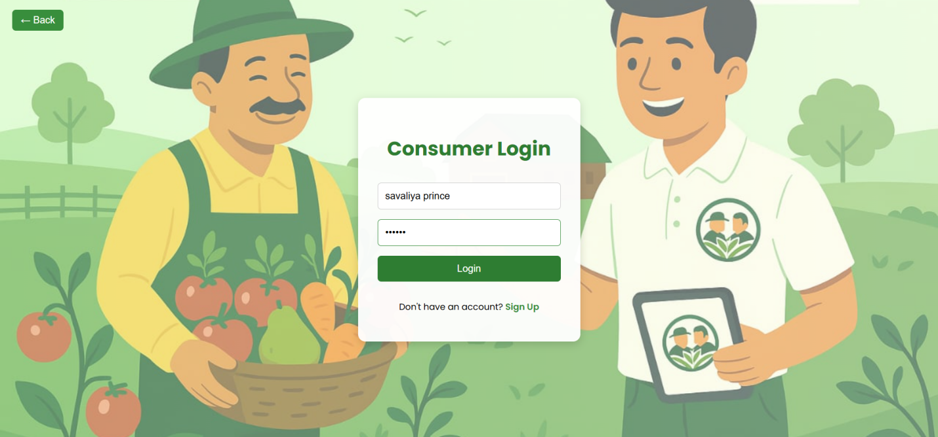

* **Consumer logs in using their email and password.**

1. **Consumer’s Home Page**

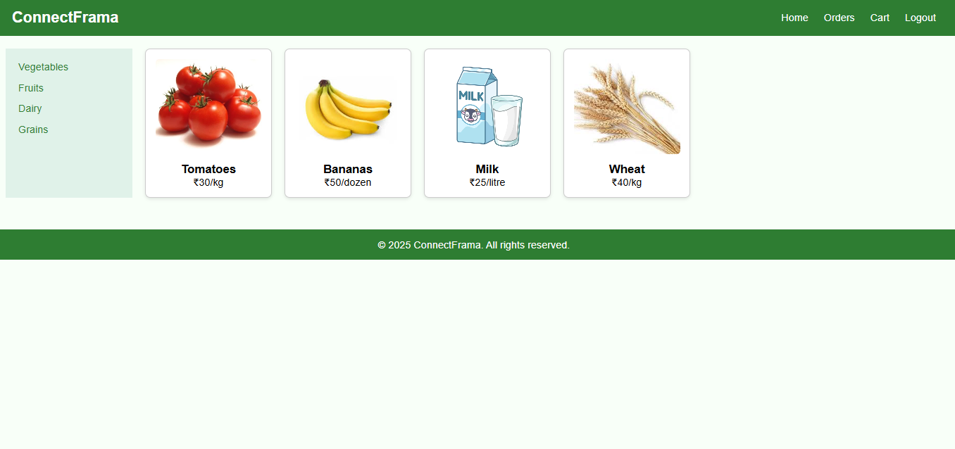

* **Consumer dashboard showing available products like vegetables, fruits, dairy and grains.**

1. **Farmer Sign Up Page**

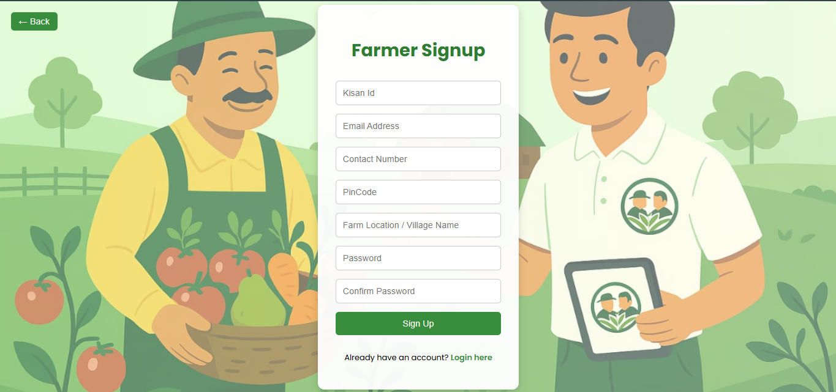

* **Farmer signup page allowing farmers to register on the platform.**

1. **Farmer Sign Up Credentials**

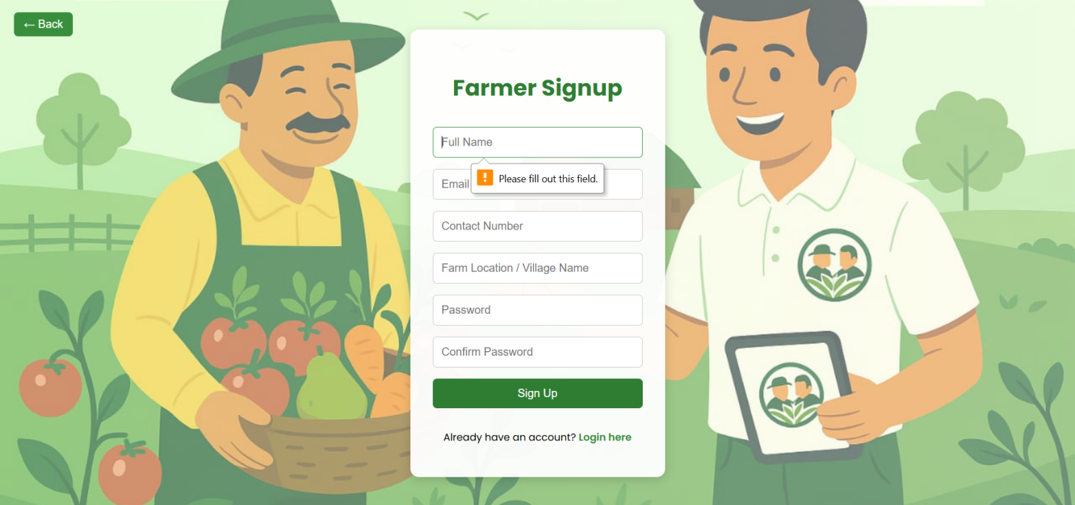

* **Farmer enters personal and location details to create an account.**

1. **Farmer Sign Up Success Message**

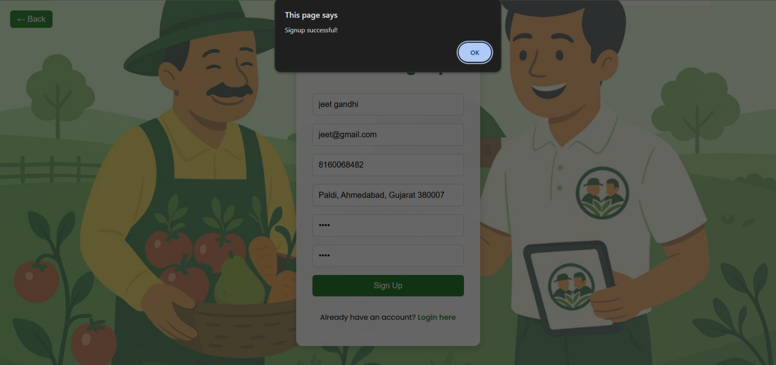

* **Confirmation message after successful farmer registration.**

1. **Farmer Log In**

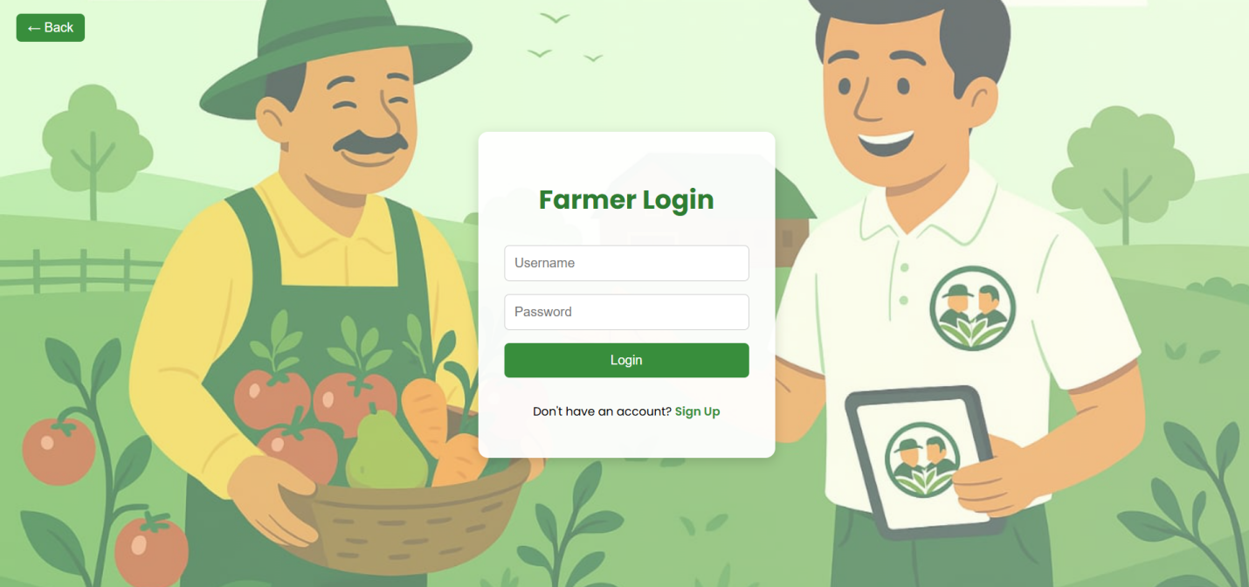

* **Farmer login page to access their profile.**

1. **Log In Credentials**

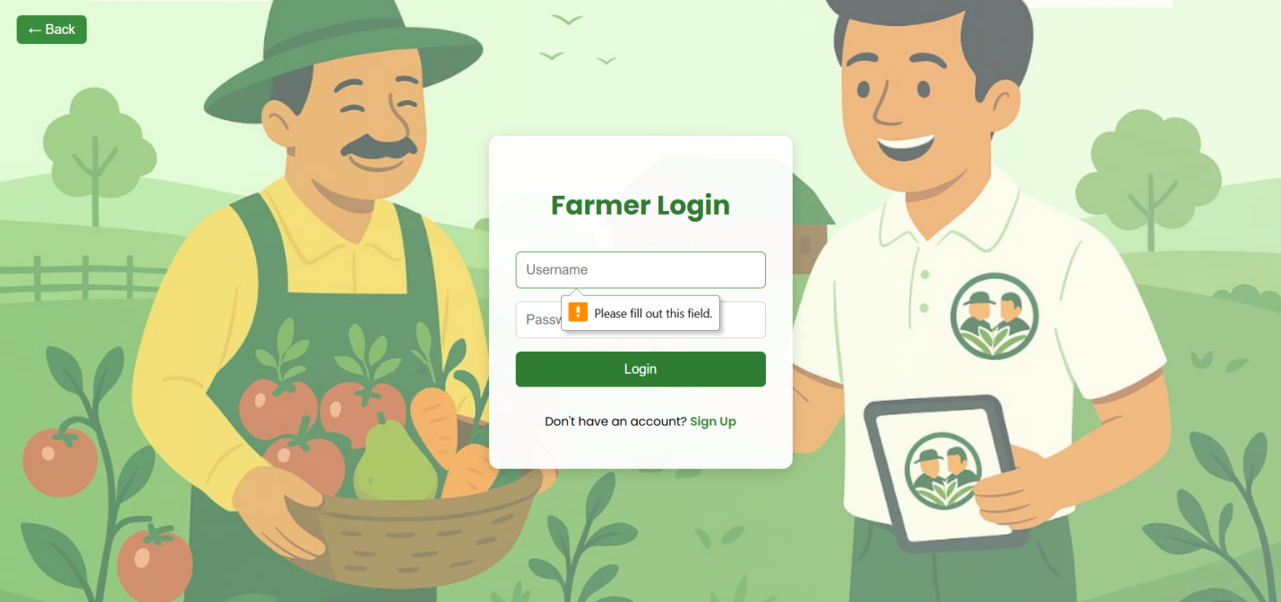

* **Farmer inputs login credentials for authentication.**

1. **Login Done**

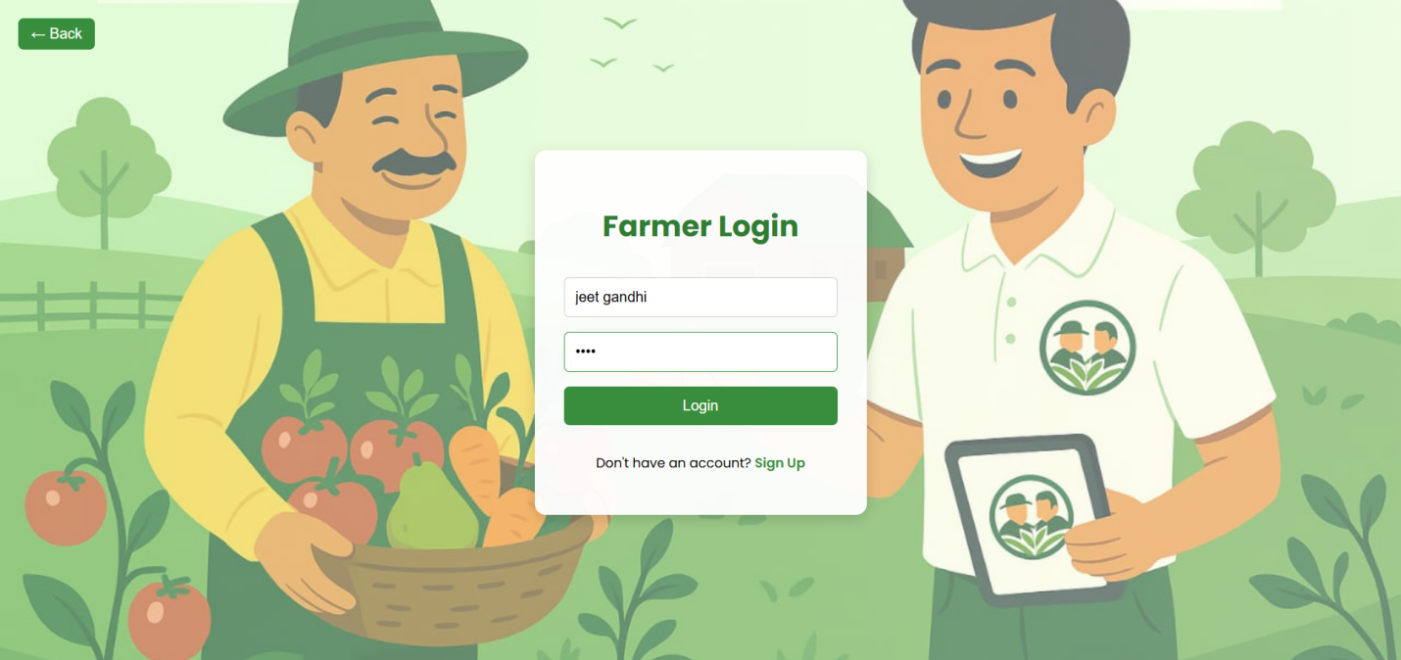

* **Farmer successfully logs in and accesses the platform.**

**Data Development**

**ER Diagram:**

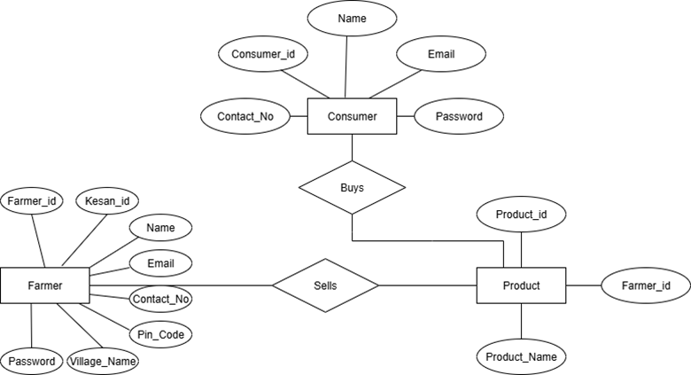

**Database Dictionary**

|  |  |  |  |  |
| --- | --- | --- | --- | --- |
| **Column Name** | **Data Type** | **Data Size** | **Constrains** | **Description** |
| consumer_id | Int(11) | 11 | Primary Key | Unique ID for each consumer |
| name | Varchar(30) | 30 | Not Null | Name of consumer |
| email | Varchar(30) | 30 | Not Null | Used for login & contact |
| contact_no | Int(10) | 10 | Not Null | Phone number for contact |
| password | Varchar(100) | 100 | Not Null | For secure login |

1. **Consumer Table :**
2. **Farmer Table :**

|  |  |  |  |  |
| --- | --- | --- | --- | --- |
| **Column Name** | **Data Type** | **Data Size** | **Constrains** | **Description** |
| farmer_id | Int(10) | 10 | Primary Key | Unique ID for each farmer |
| kisan_id | Int(13) | 13 | Not Null | Govt ID for farmer verification |
| name | Varchar(50) | 50 | Not Null | Name of farmer |
| email | Varchar(50) | 50 | Not Null | For login or communication |
| contact_no | Int(10) | 10 | Not Null | Farmer’s phone number |
| pincode | Int(07) | 07 | Not Null | Farmer’s area code |
| village_name | Varchar(100) | 100 | Not Null | Farmer’s village location |
| password | Varchar(100) | 100 | Not Null | For secure login |

**3. Product Table :**

|  |  |  |  |  |
| --- | --- | --- | --- | --- |
| **Column Name** | **Data Type** | **Data Size** | **Constrains** | **Description** |
| product_id | Int(10) | 10 | Primary Key | Unique ID for each product |
| farmer_id | Int(10) | 10 | Foreign Key | Links product to farmer |
| product_name | Varchar(100) | 100 | Not Null | Product name or title |

**Flow Diagram**

